外审完成后给平台给作者一次返修邮件正文内容：
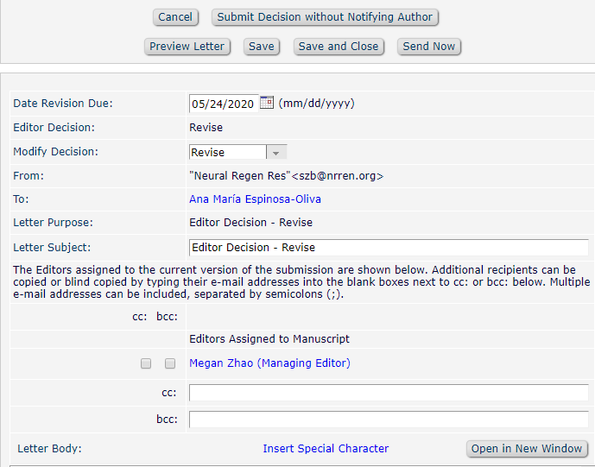
Ref.: Ms. No. NRR-D-20-
Manuscript Title
Neural Regeneration Research

Dear %TITLE% %LAST_NAME%,

Thank you for submitting to Neural Regeneration Research. Your manuscript will be considered to be accepted after your revision.

For your guidance, reviewers' comments are appended below.

If you decide to revise the work, please submit a list of changes or a rebuttal against each point which is being raised when you submit the revised manuscript.

According to reviewers' comments, the quality of the manuscript in terms of language needs to be checked by professional proof reader or native English speaker, so you are invited to make further revision concerning the English usage and grammar. (选择性发送)

Your revision is due by %DATE_REVISION_DUE%. If we do not hear from you within this period, we will consider it your non-desire to continue the article with us. Please also note that submission of revised article does not guarantee its final acceptance by the journal.

To submit a revision and copyright agreement, go to https://www.editorialmanager.com/nrr/ and log in as an Author. You will see a menu item call Submission Needing Revision. You will find your submission record there.

Yours sincerely

The editorial office
Neural Regeneration Research
Website: http://www.nrronline.org/
Email: szb@nrren.org

Reviewers' comments:

Reviewer #1:
Reviewer #2:
Reviewer #3: .

%ATTACH_FOR_AUTHOR_DEEP_LINK_INSTRUCTIONS%
%ATTACH_FOR_AUTHOR_DEEP_LINK%

附件内容
Reply to the reviewers’ comments
Reviewer #1：
Reviewer Number | Original comments of the reviewer | Reply by the author(s) | Changes done on page number and line number

Sending arevised manuscript :www.nrronline.org/contributors.asp#srm
《中国神经再生研究（英文版）》（NRR）杂志作者文章首次返修落实外审专家意见
尊敬的***作者：您好！
您的稿件编号：
文题：
- 十分感谢您对《中国神经再生研究（英文版）》杂志的信任，感谢您向本刊投稿。
- 本刊外审过程中有6-8位小同行专家参与审稿，我们将其中有效专家审稿意见发给您。
- 您应针对专家意见“点对点”一一回复，详细修改。
（1）同意专家意见请说明如何修改的，并在回修单上标注修改处为XX页XX处；；
（2）不同意专家意见应给出充分的理由说明，修改后文章经专家再审后决定您的稿件是否被采用。
（3）在文中说明:修改部分的单词要加下划线，指明所更改的内容及所在段落。
- 专家审稿内容见附件。

《中国神经再生研究（英文版）》(NRR)杂志作者首次返修及修改后稿件（1修稿件）
作者： |  | 稿号：
文题：
审稿专家意见1：

审稿专家意见2：

审稿专家意见3：

作者需要对审稿专家意见一一逐条回答：
专家意见 | 作者对修改内容的逐条回答 |  | 修改在XX页XX处 | 对没修改内容的解释

